The Chromatic Scale –taught by Libby April 18, 2016

There are 12 notes in the chromatic scale. They just keep repeating in the same pattern.

If you begin on A, the notes of the chromatic scale are:

A A# B C C# D D# E F F# G G#/
Bb Db Eb Gb Ab

- Remember that each “accidental” has two names. The same note can be either a sharp or a flat, depending on the key signature of the song.
- “Bacon and Eggs”: there is no sharp or flat between B and C; there is no sharp or flat between E and F.
- Practice saying the notes of the chromatic scale as you move fret by fret starting at the open note for each string: G, C, E and A. Name the accidentals using sharps as you ascend, and using flats as you descend. (If you can name the notes as quickly going down as you can name them going up, then you know your chromatic scale!!)
- You can play chromatic scales moving across the strings—not just going up and down individual strings. Here is a video from Ukulele Mike showing how to play the C chromatic scale across the strings. https://www.youtube.com/watch?v=RIRHd9PchIw

Knowing the chromatic scale unlocks the fretboard. It will be a foundation for learning moveable chord shapes and for playing melody.

Here is an excellent explanation of the chromatic scale from the website kauairainbow.com.

All The Notes On All The Strings

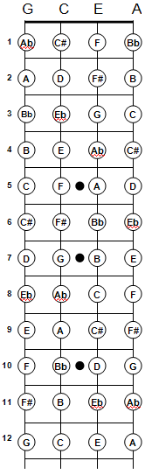 | You don't need to memorize this diagram. But you do need to understand how to find the notes. To do this, you'll need to know two things: (1) the open tones of each string, and (2) the notes of the chromatic scale.  (1). The open tones (the note that sounds when the string is unfretted) of the four strings are G, C, E, and A. This is the familiar "My Dog Has Fleas" melody that all ukulele players know.  (2). Each time you move one fret higher on a string, you move one note higher on the chromatic scale. The twelve notes of the chromatic scale are A, A#/Bb, B, C, C#/Db, D, D#/Eb, E, F, F#/Gb, G, G#/Ab.  Looking at the diagram, you can see how the chromatic scale extends up the fretboard, one note at a time, starting at the open tone for each string.  If you're wondering why the chromatic scale doesn't always have a flat or sharp between each of the "natural" notes of the scale, take a look at the scale as it shows up on a piano keyboard. The white keys are the natural notes (A, B, C, ...) and the black keys are the sharps and flats. The irregular pattern of sharps and flats is represented in the irregular pattern of black keys on the piano. You can see that there are no sharps or flats between B and C, or between E and F.

